DAVID MEERMAN SCOTT
Internationally-Acclaimed Author of Ten Books
Real-Time Marketing & Social Sales Strategies That Work
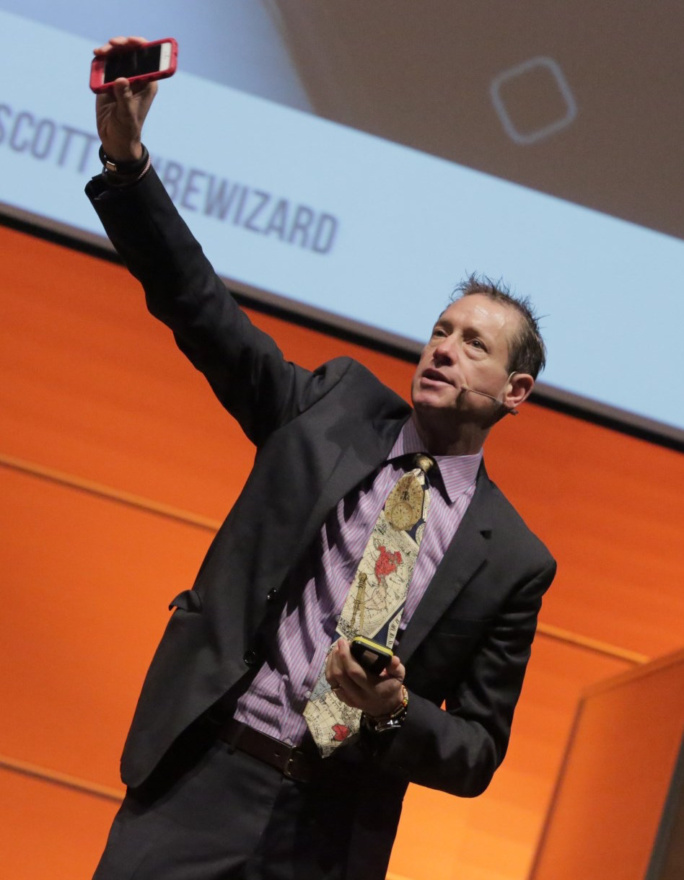
- The way most companies sell is out of alignment with the way people buy. Be fearless and close the gap with social selling & content marketing strategies & tactics.
- Real-Time rules: speed and agility win – not the biggest budget! Learn low-/no- cost ways to build business and get attention.
- Stand out, spread ideas, win hearts & minds, drive sales with content that gets noticed when people are ready to buy.
- Be fearless – embrace a Real-Time mindset organization-wide. Generate interest & new relationships in minutes – not months.

SPEECH DESCRIPTIONS

BE FEARLESS: REAL-TIME Marketing & PR GET RESULTS
Break out and breakthrough by engaging customers on their own terms. Business is different today. We all know it. It’s a scary idea to set aside outdated beliefs and dusty old strategies but those old ways are costing you money. It’s time to be fearless. Get over the fear of trying something new, the fear of change, and the fear that it might not work the first time. David Meerman Scott leads the way and outlines fresh, measurable and low- and no-cost strategies – like Newsjacking – to instantly and directly reach your audience. Scott’s informative, entertaining and high-energy presentations shine a light on the best examples of success from a wide variety of large and small organizations – from business-to-business outfits to rock bands, nonprofits to entrepreneurial growth businesses. He’ll energize the audience and show people how to get found at the exact moment buyers are looking. Social media are the tools but it’s a Real-Time mindset that drives strategy in a world where speed and agility win – not the biggest budget. Shift from the controlled and message-driven advertising/PR paradigm and learn to win hearts and minds by creating content that people are eager to consume and share.

FEARLESS SALES – POWERING SOCIAL SELLING IN REAL-TIME
The way most companies sell is not aligned with the way people buy. That’s a problem. Buyers are bypassing the traditional selling model altogether. They’re learning for themselves about your products/services, your competitors, and what customers say about you (whether true or not!). At the same time, the boundary between the sales and marketing efforts has gotten blurry – so blurry it’s almost not there. These changes have driven a revolution in how sales and service are done. It’s time to stop thinking in the past and get fearless about how to engage customers. Social selling is the most effective approach and speed is the ultimate competitive weapon. Nothing is faster than Real-Time because you reach buyers on their timetable, not yours. It’s natural to fear trying something new or different – change is never easy. David Meerman Scott shows how the best salespeople (and sales organizations) have become information curators – communicating by delivering the precise information buyers need at just the right time and in just the right way. Real-Time social selling gains more customers with fewer resources and David offers concrete examples of small and large companies achieving sales success right now.
BEYOND THE KEYNOTE
David Meerman Scott is available to deliver sales and marketing workshops which provide a step-by-step framework for implementing Real-Time sales or marketing/PR strategies. These sessions drill down to explore tactical, actionable plans to reach buyers directly and in Real-Time. Learn powerful ways to create content that gets attention using blogs, viral marketing, podcasts, online video, search engine marketing and online thought-leadership. Programs are custom-tailored to suit unique needs. Please inquire for specific details.

REAL-TIME MINDSHIFT – IN-PERSON TEAM COACHING SESSION
Get your team together and roll up your sleeves! David Meerman Scott comes to your office to coach your team to re-imagine ways to reach your audience. Learn to take advantage of new Real-Time marketing and sales realities. Then set your
organization up to exceed your goals by implementing new low-cost (and no-cost) strategies and tactics in that are proven to
grow business. By the end of the day with David, your team will be eager to implement the new ideas. Everybody will be armed with a clear set of objectives and actionable & fresh Real-Time approaches that create immediate results. The live coaching session works because David tailors each one from the ground up for your specific needs. He’s conducted events at dozens of varied organizations around the world including Dow Jones, Microsoft, United States Marine Corps, NY Islanders, Century 21, Jackson Healthcare, National Geographic, and many more.

DAVID MEERMAN SCOTT’S STORY

David Meerman Scott is a master of the new rules for growing business, spreading ideas and generating attention in our always-on, Web-driven world. Advance planning is out – speed and agility are IN! Scale and media buying power are no longer a decisive advantage. Instead, Real-Time is the mindset – and content matters – you are what you publish! Those who can be fearless and put away old strategies and tactics in favor of a new way will reap the rewards.

David is an internationally acclaimed sales and marketing/PR strategist whose books and blog are must-reads for professionals and organizations seeking to stand out, get noticed and capture hearts and minds for their products, services and ideas. He is author or co-author of ten books (including three international bestsellers) with one million books in print. The New Rules of Marketing & PR, now in its 6th edition with over 350,000 copies sold, is a modern business classic that is available in 29 languages from Albanian to Vietnamese and used as a text in hundreds of universities and business schools worldwide. Real-Time Marketing & PR is a Wall Street Journal bestseller while Newsjacking, and The New Rules of Sales and Service have each broken new ground with fresh ideas. David is also co-author of Marketing the Moon (being made into a feature film entitled The Men Who Sold the Moon) and Marketing Lessons from The Grateful Dead.

David’s ideas have captured the attention of the most respected firms and organizations all over the world. He is an in-demand keynote speaker on sales and marketing who has appeared in more than 41 countries and on all seven continents. His tailored and high energy presentations are an entertaining and urgent call to action where fresh ideas are punctuated rapid-fire with bold images, video and success stories to energize audiences. He inspires them to set old ideas and fear aside and use these new tools and Real-Time strategies to achieve real, measurable, no-cost results and seize the initiative, open new channels and grow their brand. David’s groundbreaking strategies don’t just slap social media onto dusty old strategies – they reinvent the way to engage the marketplace. Audiences walk away knowing how to use blogs, YouTube, Facebook, Twitter, Big Data and the strategies like Newsjacking to engage the media, crowd-source product development, increase sales, exert influence, disseminate ideas, and command premium prices by using speed and immediacy as a strategic weapon.
David Meerman Scott is a lifelong globalist with real-world experience and an eye for the bigger marketplace. He moved to Tokyo at age 26 to establish the Japan office of a Wall Street Real-Time economic advisory firm. He worked for global Real-Time media companies in Tokyo for seven years and Hong Kong for two. David was Asia marketing director for Knight-Ridder in the mid-1990s before moving to the Boston area where he was marketing VP for two publicly-traded U.S. companies. Losing his job following the sale of NewsEdge to Thomson Reuters delivered David the gift of reinvention as a strategist advising organizations on the new realities of agile, Real-Time business.

In addition to his work as a writer, researcher and international speaker, David is a co-founder and partner in Signature Tones, a sonic branding studio. Signature Tones works with clients to create sonic logos and original music for use perfectly in tune with their brand. Sonic branding includes original music that is used in videos, podcasts, products and services, as walk on music for speaking engagements, in TV and radio commercials. David is also an advisor to emerging companies who are working to transform their industries by delivering disruptive products and services. Besides delivering success as a member of the board of directors of NewsWatch KK (successfully sold to Yahoo Japan) and Kadient (successfully merged with Sant), and on the board of advisors of Eloqua (successful IPO in mid-2012 and sale to Oracle in early 2013) and GrabCAD (successfully sold to Stratasys in mid-2014), his current portfolio of advisory clients includes HubSpot, where he serves as Marketer in Residence (successful IPO in October 2014), digital selling firm Vengreso, Mynd, RISEcx, Set The Set, SlapFive, VisibleGains, ExpertFile and GutCheck as well as non-profits including the Grateful Dead Archive at University of California/Santa Cruz and HeadCount.

IMPORTANT NOTE: David Meerman Scott uses his full name professionally. Meerman is his middle name. When you first refer to him, please use his full name - "David Meerman Scott." After that, feel free to refer to him as "David" or "Scott" or "Mr. Scott".

Keywords: Business Growth, Business Strategy, Communication Strategy, Competition, Author, Entrepreneurship, Inspiration, Marketing & PR, Inbound Marketing, Content Marketing, Sales Growth, Social Media, Social Selling, Sonic Branding, The Business Environment, Real-Time Marketing, PR Strategy, and Agile Selling.

(12/17)

